**CKS0001 COKOINO motor drive shield for Uno R3**

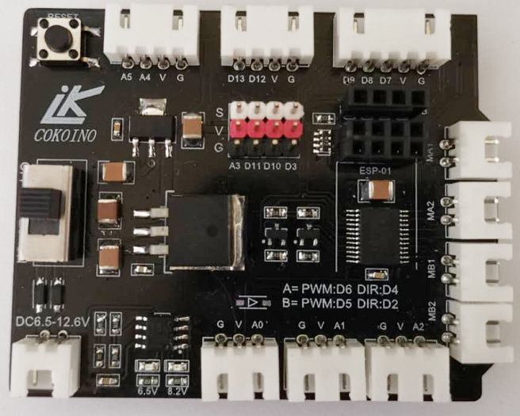

**1、Overview**

COKOINO motor drive shield can be inserted directly into arduino UNO R3. The HX2.54 interface on the expansion board can quickly connect the sensor module externally;It has a large current 5V regulator chip, which can drive multiple servos; and it reserves a serial port interface, which can directly plug in the Bluetooth module; reserves the WiFi interface, which can directly the esp-01 module into the motor drive shield;

The motor drive shield integrates the TB6612 motor drive system to drive two motors. And the battery indicator LED is integrated on the board to help us understand the battery status of its connected battery. Combined with the arduino UNO R3 motherboard and other modules, it can be combined into a variety of interesting products, such as: smart Bluetooth control car, smart WiFi control car, and more.

**2、Specification**

(1) External voltage: DC6.5-12.6V, recommended working voltage 9V, anti-reverse connection  
(2) 5V output current: up to 5A  
(3) Motor drive chip: TB6612FNG, input DC6.5-12.6V, drive average current is 1.2A  
(4) Interface: XH2.54 connector, 2.54mm pin header  
(5) wifi interface power supply: use AMS1117-3.3V, the maximum output current 1A  
(6) Compatible motherboard: arduino UNO R3  
(7) Compatible with all COKOINO sensors with HX-2.54 interface

**3、Size（mm）**

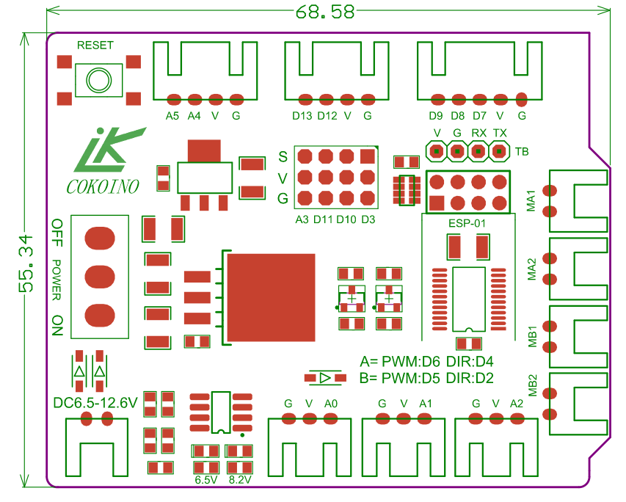

1. **Expanded board screen printing instructions**

(1) MA1\MA2\MB1\MB2 interface:Connect the motor of DC6.5-12.6V  
(2) G\V\A0 interface: corresponding to UNO R3 A0 pin, can be connected to single analog signal and digital signal module  
(3) G\V\A1 interface: corresponding to UNO R3 A1 pin, can be connected to single analog signal and digital signal module  
(4) G\V\A2 interface: corresponding to UNO R3 A2 pin, can be connected to single analog signal and digital signal module  
(5) G\V\D7\D8\D9 interface: corresponding to UNO R3 7-8 pin, can be connected to three-way inspection module  
(6) G\V\D12\D13 interface: corresponding to UNO R3 12-13 pin, can be connected to the ultrasonic module  
(7) G\V\A4\A5 interface: corresponding UNO R3 A4-5 pin (IIC), can be connected to IIC 1602LCD module  
(8)V\G\TX\RX interface: corresponding to UNO R3 serial port, can be connected to Bluetooth module  
(9) ESP-01 interface: corresponding to UNO R3 serial port, can be connected to ESP-01 wifi module  
(10) RESET: Corresponding to UNO R3 reset button  
(11) 6.5V: The battery is lit above 6.5V, 8.2V: the battery is 8.2 or higher and V is lit.  
(12) Power: Power switch, dial to ON to turn on the power, dial to OFF to turn off the power  
(13)V, G: DC5V/5A power output positive, DC5V/5A power output negative  
(14) DC6.5-12.6V: main power interface

1. **Instructions**

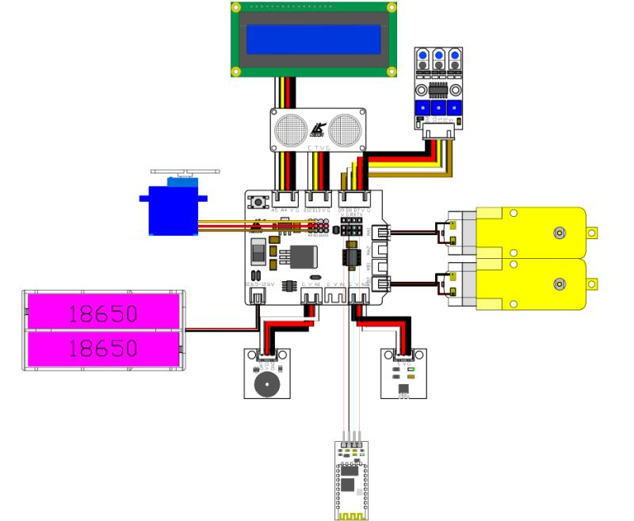

|  |  |  |
| --- | --- | --- |
| UNO R3 PIN | TB6612 PIN | MA1、MA2 of shield |
| 6=PWM | 23（PWMA） | Control motor speed |
| 4=HIGH | 21(AIN1)=LOW  22(AIN2)=HIGH | Motor forward |
| 4=LOW | 21(AIN1)=HIGH  22(AIN2)=LOW | Motor reversal |

|  |  |  |
| --- | --- | --- |
| UNO R3 | TB6612 | MB1、MB2of shield |
| 5=PWM | 15（PWMB） | Control motor speed |
| 2=HIGH | 17(BIN1)=LOW  16(BIN2)=HIGH | Motor forward |
| 2=LOW | 17(BIN1)=HIGH  16(BIN2)=LOW | Motor reversal |

Arduino代码：

void setup() //Set the parameter function, only run once after the program starts

{

pinMode(6, OUTPUT); //Set pin 6 to output mode

pinMode(4, OUTPUT); //Set pin 4 to output mode

pinMode(5, OUTPUT); //Set pin 5 to output mode

pinMode(2, OUTPUT); //Set pin 2 to output mode

}

void loop() //The main loop function, the program will continue to run in this function after executing this function

{

analogWrite(6,200); //Pin 6 output high and low level PWM signal with 200:55 duty cycle

digitalWrite(4,HIGH); //Pin 4 output high level

analogWrite(5,200); //Pin 5 output high and low level PWM signal with 200:55 duty cycle

digitalWrite(2,HIGH); //Pin 2 output high level

delay(2000); //Delay 2000 milliseconds

analogWrite(6,200); //Pin 6 output high and low level PWM signal with 200:55 duty cycle

digitalWrite(4,LOW); //Pin 4 output high level

analogWrite(5,200); //Pin 5 output high and low level PWM signal with 200:55 duty cycle

digitalWrite(2,LOW); //Pin 2 output high level

delay(2000); //Delay 2000 milliseconds

}

Remarks: Attached to the TB6612FNG specification.

1. **The use of Bluetooth interface of the shield**

When the expansion board is directly plugged into the UNO R3 motherboard, the Bluetooth interface is directly connected to the serial port of UNO R3. Please do not connect the Bluetooth module to this interface when uploading the code, otherwise the code cannot be uploaded.

1. **The use of wifi interface of the shield**

The Wifi interface of shield can be directly plugged into an esp-01 module. When the UNO R3 motherboard is connected, the esp-01 module will be enabled by the hardware on the expansion board to the flash boot mode. The esp-01 interface is directly connected to the serial port of UNO R3. Please do not connect the esp-01 module to this interface when uploading the code. Otherwise, the code cannot be uploaded.

**8、schematic diagram**

